**CONTENT ASSESSMENT 4**

**Name:** Naseer Almargan

**Date:** 08-06-2020

**Question No.1:**

**Describe the concept of arithmetic overflow.**

**Ans:**

Arithmetic overflow is the result of calculation which exceeds the memory space designated to acquire it. For example. If two 5-bit numbers are adding and their result is 6-bit or more than 5-bit then arithmetic overflow occurred. The arithmetic flow occurs during the addition of binary numbers. In computer architecture when system is processing, all logic operations are occurring at a very fast rate so the arithmetic overflow occurs.

Arithmetic flow occurs in two types. Signed and unsigned overflow. Straightly signed overflow occurs in signed numbers while unsigned overflow occurs in unsigned numbers. Arithmetic overflow has some rules of occurring for 2’s complement that are given below:

* If adding numbers are both positive then the result is negative and overflow has occurred.
* If adding numbers are both negative then the result is positive and overflow has occurred.
* If the sign of adding operands are different then overflow does not occur.

**Question No.2:**

**Draw the diagram for adding two 5-bit binary values using full adders that has the ability to detect whether an overflow occurs.**

**Ans:**

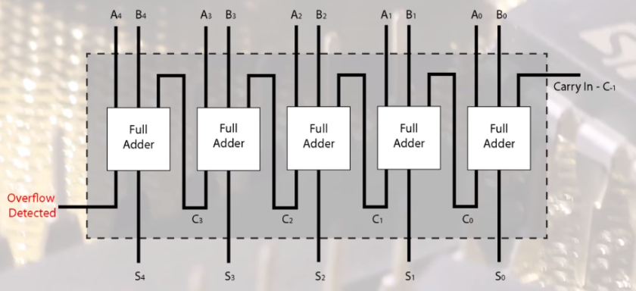

**Question No.3:**

**draw the truth table for your diagram.**

**Ans:**